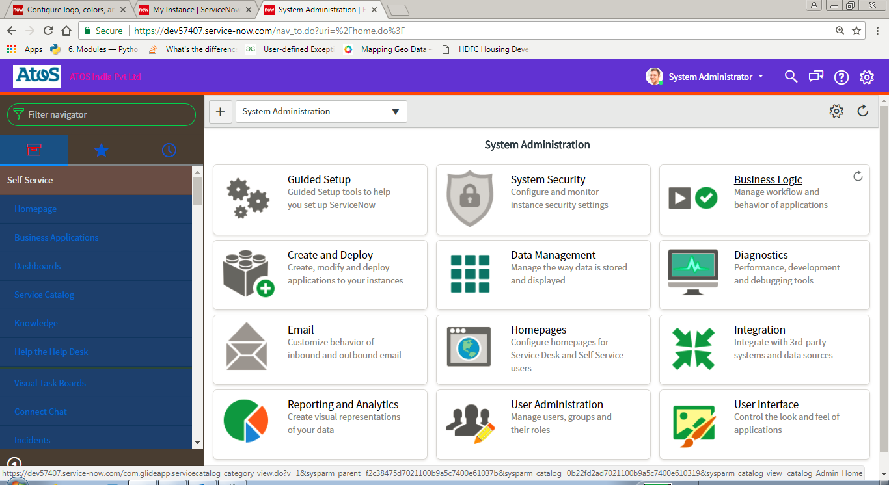

You can use the Basic Configuration UI16 module to brand your instance with your company logo and colors and set basic system defaults. This place is the best starting point if you are setting up your instance for the first time or if you have recently enabled UI16.

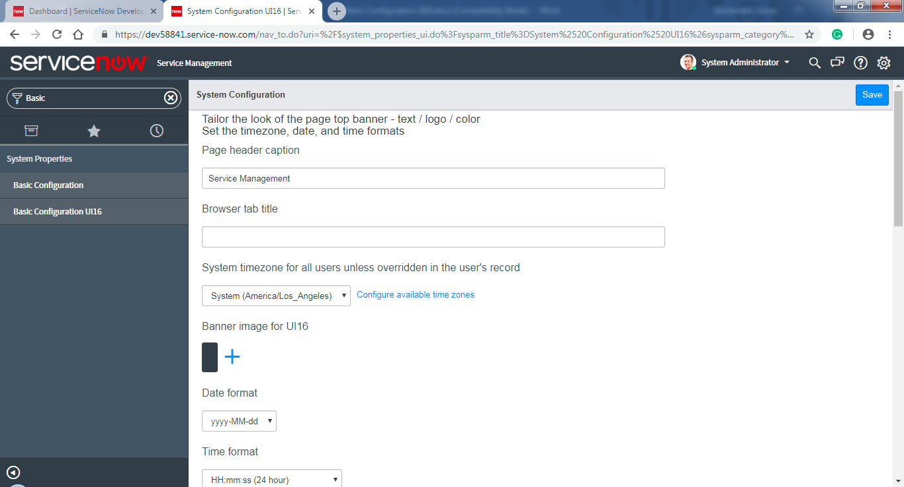

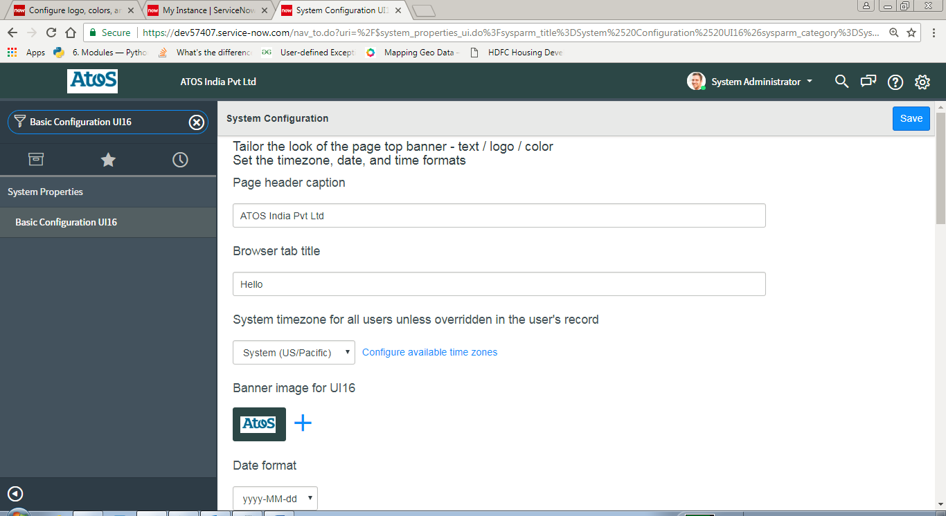
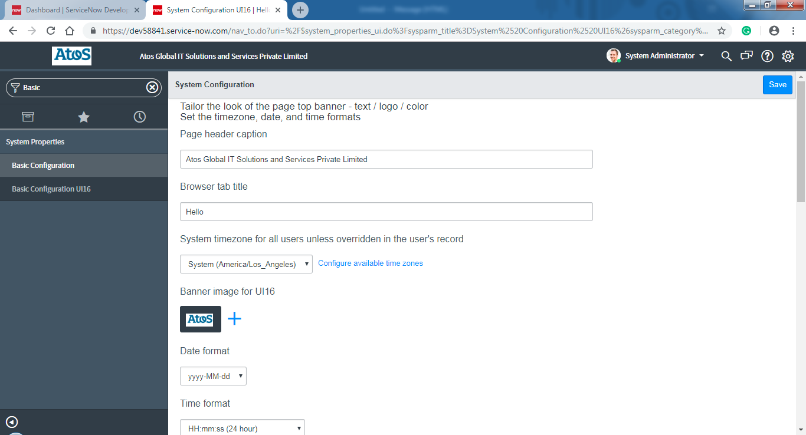
Basic Configuration UI16
https://docs.servicenow.com/bundle/jakarta-platform-user-interface/page/administer/navigation-and-ui/task/t_ConfigureLogoColorsSysDfltsUI16.html

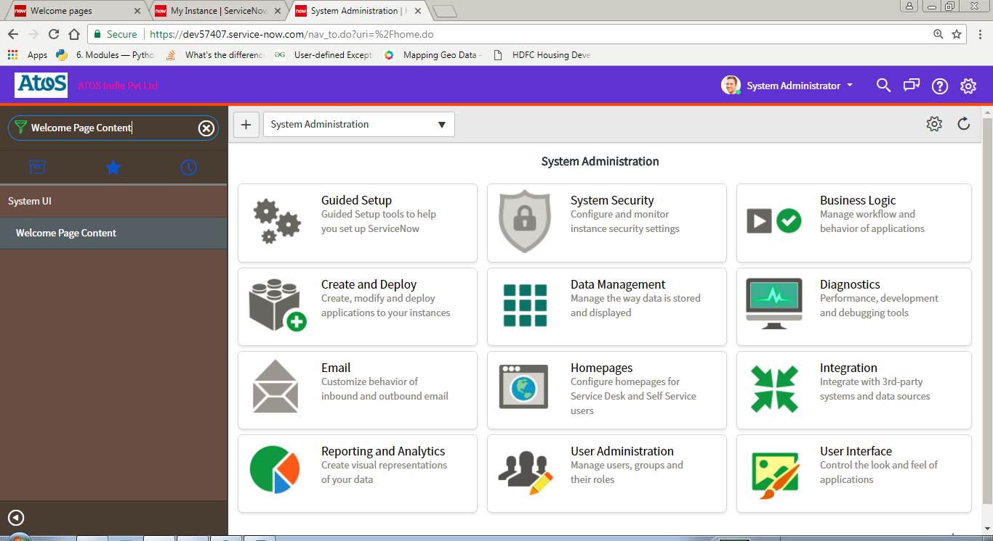
https://docs.servicenow.com/bundle/jakarta-platform-user-interface/page/administer/navigation-and-ui/concept/c_WelcomePageContent.html
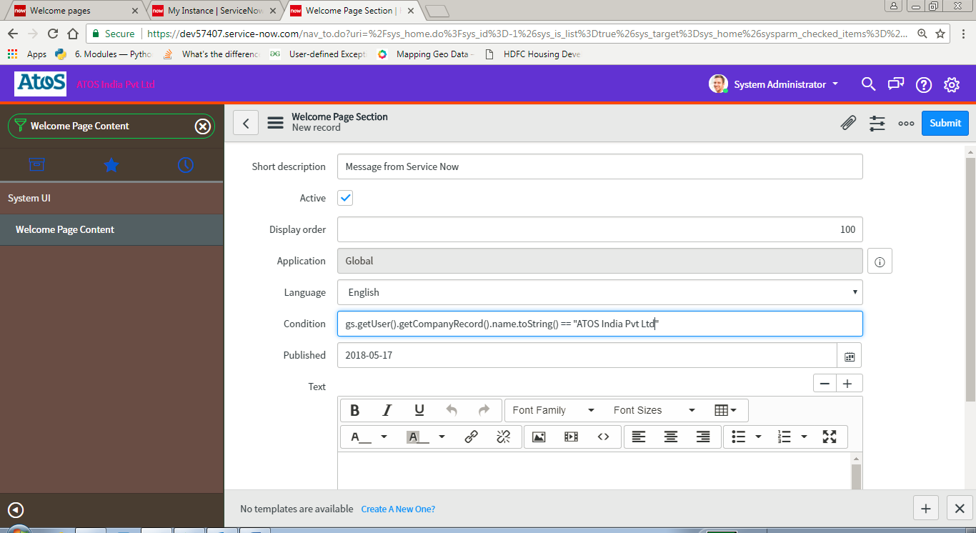
https://docs.servicenow.com/bundle/jakarta-platform-user-interface/page/administer/navigation-and-ui/concept/c_MapPages.html

